Barham Primary School

Mental Health and Wellbeing

Policy

Safe, Happy, Learning

At Barham Primary School we have the right to:

Article 19: Be Safe

Articles 28 and 29: Education

Policy summarised by

SENDCo
Approved by full governing body on:

December 2023

To be reviewed

December 2024

…..
embedding

excellence

Barham Primary School
Mental Health and Wellbeing Policy

“Embedding EXCELLENCE”
This policy was written in consultation with staff, pupils, parents and professionals involved in mental health and wellbeing.

Purpose of the policy

At Barham Primary School, we are an inclusive school committed to supporting the emotional health and wellbeing of our pupils, staff and families.
We have a supportive and caring ethos and our approach is respectful and kind, where each individual and contribution is valued.
At Barham Primary School we know that everyone experiences life challenges that can make us vulnerable and at times, anyone may need additional emotional support. We take the view that positive mental health is everybody’s business and that we all have a role to play.
To promote positive mental and emotional wellbeing by providing information and support.
To create a shared understanding of all aspects of mental health.
Enable those with mental health related issues to self-disclose and seek support in a safe confidential manner.
Offer guidance and strategies, along with the support of Mental Health First Aiders, to support pupils and staff to be mentally healthy.
Create a culture to support and maintain positive mental health and wellbeing.

What is the Mental Health and Wellbeing Policy?
The Mental Health and Wellbeing Strategy is a guide to define ‘how’ we are expected to support children and staff with mental health and wellbeing and ‘what’ practice we implement to support mental health and wellbeing.
The strategy details the systems in place to ensure that mental health and wellbeing is embedded into our culture to support the children and staff at Werrington Primary School.

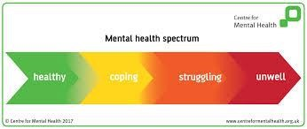

What do we mean by mental health?
Mental Health is “the emotional and spiritual resilience which enables us to enjoy life and survive pain, suffering and disappointment. It is a positive sense of wellbeing and an underlying belief in our and others dignity and worth. It is influenced by our experience and our genetic inheritance.” (World Health Organisation)
Mental health affects all aspects of life and behaviour.
Like physical health, mental health is something we all have. It can range across a spectrum from healthy to unwell; it can fluctuate on a daily basis and change over time, see above spectrum.

At Barham Primary school we:
- help children to understand their emotions and feelings better - help children feel comfortable sharing any concerns or worries
- help children socially to form and maintain relationships
- promote self-esteem and ensure children know that they count
- encourage children to be confident and ‘dare to be different’
- help children to develop emotional resilience and to manage setbacks

We promote a mentally healthy environment through:
- Promoting our school values and encouraging a sense of belonging
- Promoting pupil voice and opportunities to participate in decision-making
- Celebrating academic and non-academic achievements
- Providing opportunities to develop a sense of worth through taking responsibility for themselves and others - Providing opportunities to reflect
- Access to appropriate support that meets their needs

We pursue our aims through:
- Universal, whole school approaches
- Support for pupils going through recent difficulties including bereavement
- Specialised, targeted approaches aimed at pupils with more complex or long-term difficulties including attachment disorder

Scope
This policy should be read in conjunction with our Medical policy, safeguarding policy and our SEND policy in cases where pupils mental health needs overlap with these. This policy should also be read in conjunction with policies for Behaviour and Anti-bullying, and PSHE policies. It should also sit alongside child protection procedures.

Lead Members of Staff
Whilst all staff have a responsibility to promote the mental health of students, staff with a specific, relevant remit include:
- Silvana Mazzaschi - Special Educational Needs coordinator and Mental Health and Emotional Wellbeing Lead
- Natalie Dweh - Designated Safeguarding Lead
- The Senior Leadership Team - Deputy Designated Safeguarding Leads
- Margaret Narcisse - Emotional Literacy Support assistants -ELSA

Teaching about Mental Health
The skills, knowledge and understanding needed by our students to keep themselves mentally healthy and safe are included as part of our developmental PSHE curriculum.
The specific content of lessons will be determined by the specific needs of the cohort we are teaching but we will also use the PSHE Association Guidance to ensure that we teach mental health and emotional wellbeing issues in a safe and sensitive manner.
Barham Primary School also has a well-being 'cog' team that ensures curriculum representation across the age groups.

Targeted support
The school will offer support through targeted approaches for individual pupils or groups of pupils which may include:
- Circle time approaches and activities
- Targeted use of PSED resources
- Managing feelings resources e.g. ‘worry boxes’
- Group Work/Mental health and wellbeing groups
- ELSA support groups
- Therapeutic activities including art, lego and relaxation and mindfulness techniques - Mental Health awareness weeks

The school will make use of resources to assess and track wellbeing as appropriate including:
- Strengths and Difficulties questionnaire
- Emotional literacy scales
- CPOMs

Signposting
We will ensure that staff, pupils and parents are aware of what support is available within our school and how to access further support.

Identifying needs and Warning Signs
All staff will have the availability to flag up any concerns on CPOMs under the wellbeing section on their pupils, aimed at identifying a range of possible difficulties including:
- Attendance
- Punctuality
- Relationships
- Approach to learning
- Physical indicators
- Negative behaviour patterns
- Family circumstances
- Recent bereavement
- Health indicators

School staff may also become aware of warning signs which indicate a student is experiencing mental health or emotional wellbeing issues. These warning signs should always be taken seriously and staff observing any of these warning signs should communicate their concerns with the designated child protection and safeguarding officer or the emotional wellbeing lead as appropriate.
Possible warning signs include:
- Changes in eating / sleeping habits
- Becoming socially withdrawn
- Changes in activity and mood
- Talking or joking about self-harm or suicide
- Expressing feelings of failure, uselessness or loss of hope
- Repeated physical pain or nausea with no evident cause
- An increase in lateness or absenteeism
- Change in appearance

Working with Parents
In order to support parents we will:
- Highlight sources of information and support about mental health and emotional wellbeing on our school website
- Share and allow parents to access sources of further support e.g. through parent forums
- Ensure that all parents are aware of who to talk to, and how to get about this, if they have concerns about their child
- Make our emotional wellbeing and mental health policy easily accessible to parents
- Share ideas about how parents can support positive mental health in their children and themselves
- Keep parents informed about the mental health topics their children are learning about in PSHE and share ideas for extending and exploring this learning at home
- Support offered to parents from the Mental Health and Emotional wellbeing lead and parent liaison officer - Parent classes and workshops

Working with other agencies and partners:
As part of our targeted provision the school will work with other agencies to support children’s emotional health and wellbeing including:
- The school nurse
- Educational Psychology services
- Behaviour support through the Brent Inclusion Team
- Paediatricians
- CAMHS (Child and Adolescent Mental Health services)
- Brent Mental Health Support Team (MHST)
- Wellbeing and Emotional Support Team (WEST)
- Counselling services
- Family Support Workers
- Therapists

Training
As a minimum, all staff will receive regular training about recognising and responding to mental health issues as part of their regular child protection training in order to enable them to keep students safe.
Training opportunities for staff who require more in depth knowledge will be considered as part of our performance management process and additional CPD will be supported throughout the year where it becomes appropriate due to developing situations with one or more pupils.

Staff Identification
It is recognised at Barham Primary School that promoting staff health and emotional well-being should be an integral part of the whole school approach to mental health and wellbeing. Therefore training and signposting to materials about mental health and emotional wellbeing will be made available for all staff. An open door policy to senior leadership is always made available if staff are in need of speaking to someone about any issues of concern and a fully committed supportive governing body. An Emotional Health and Wellbeing section in the SEND file will be made available for every classroom practitioner, kitchen and domestic staff, senior leaders and governors. The file will contain informative advice about key factors understanding the important of their own emotional well-being and where to go if they need additional support / advice. Supervision and appraisal will allow for mutual communication about personal health and emotional wellbeing if both felt it is deemed necessary.

Targeted support for staff
The school will offer support through targeted approaches for individual staff or groups of staff which may include:
- Open door policy with senior leadership team
- Private meetings/ conversations with the Mental Health and Emotional wellbeing lead
- Direction to ‘Education Supports’ free, confidential support line
- Referrals to Occupational Health if required
- Directed time to support work load
- Regular contact with line manager

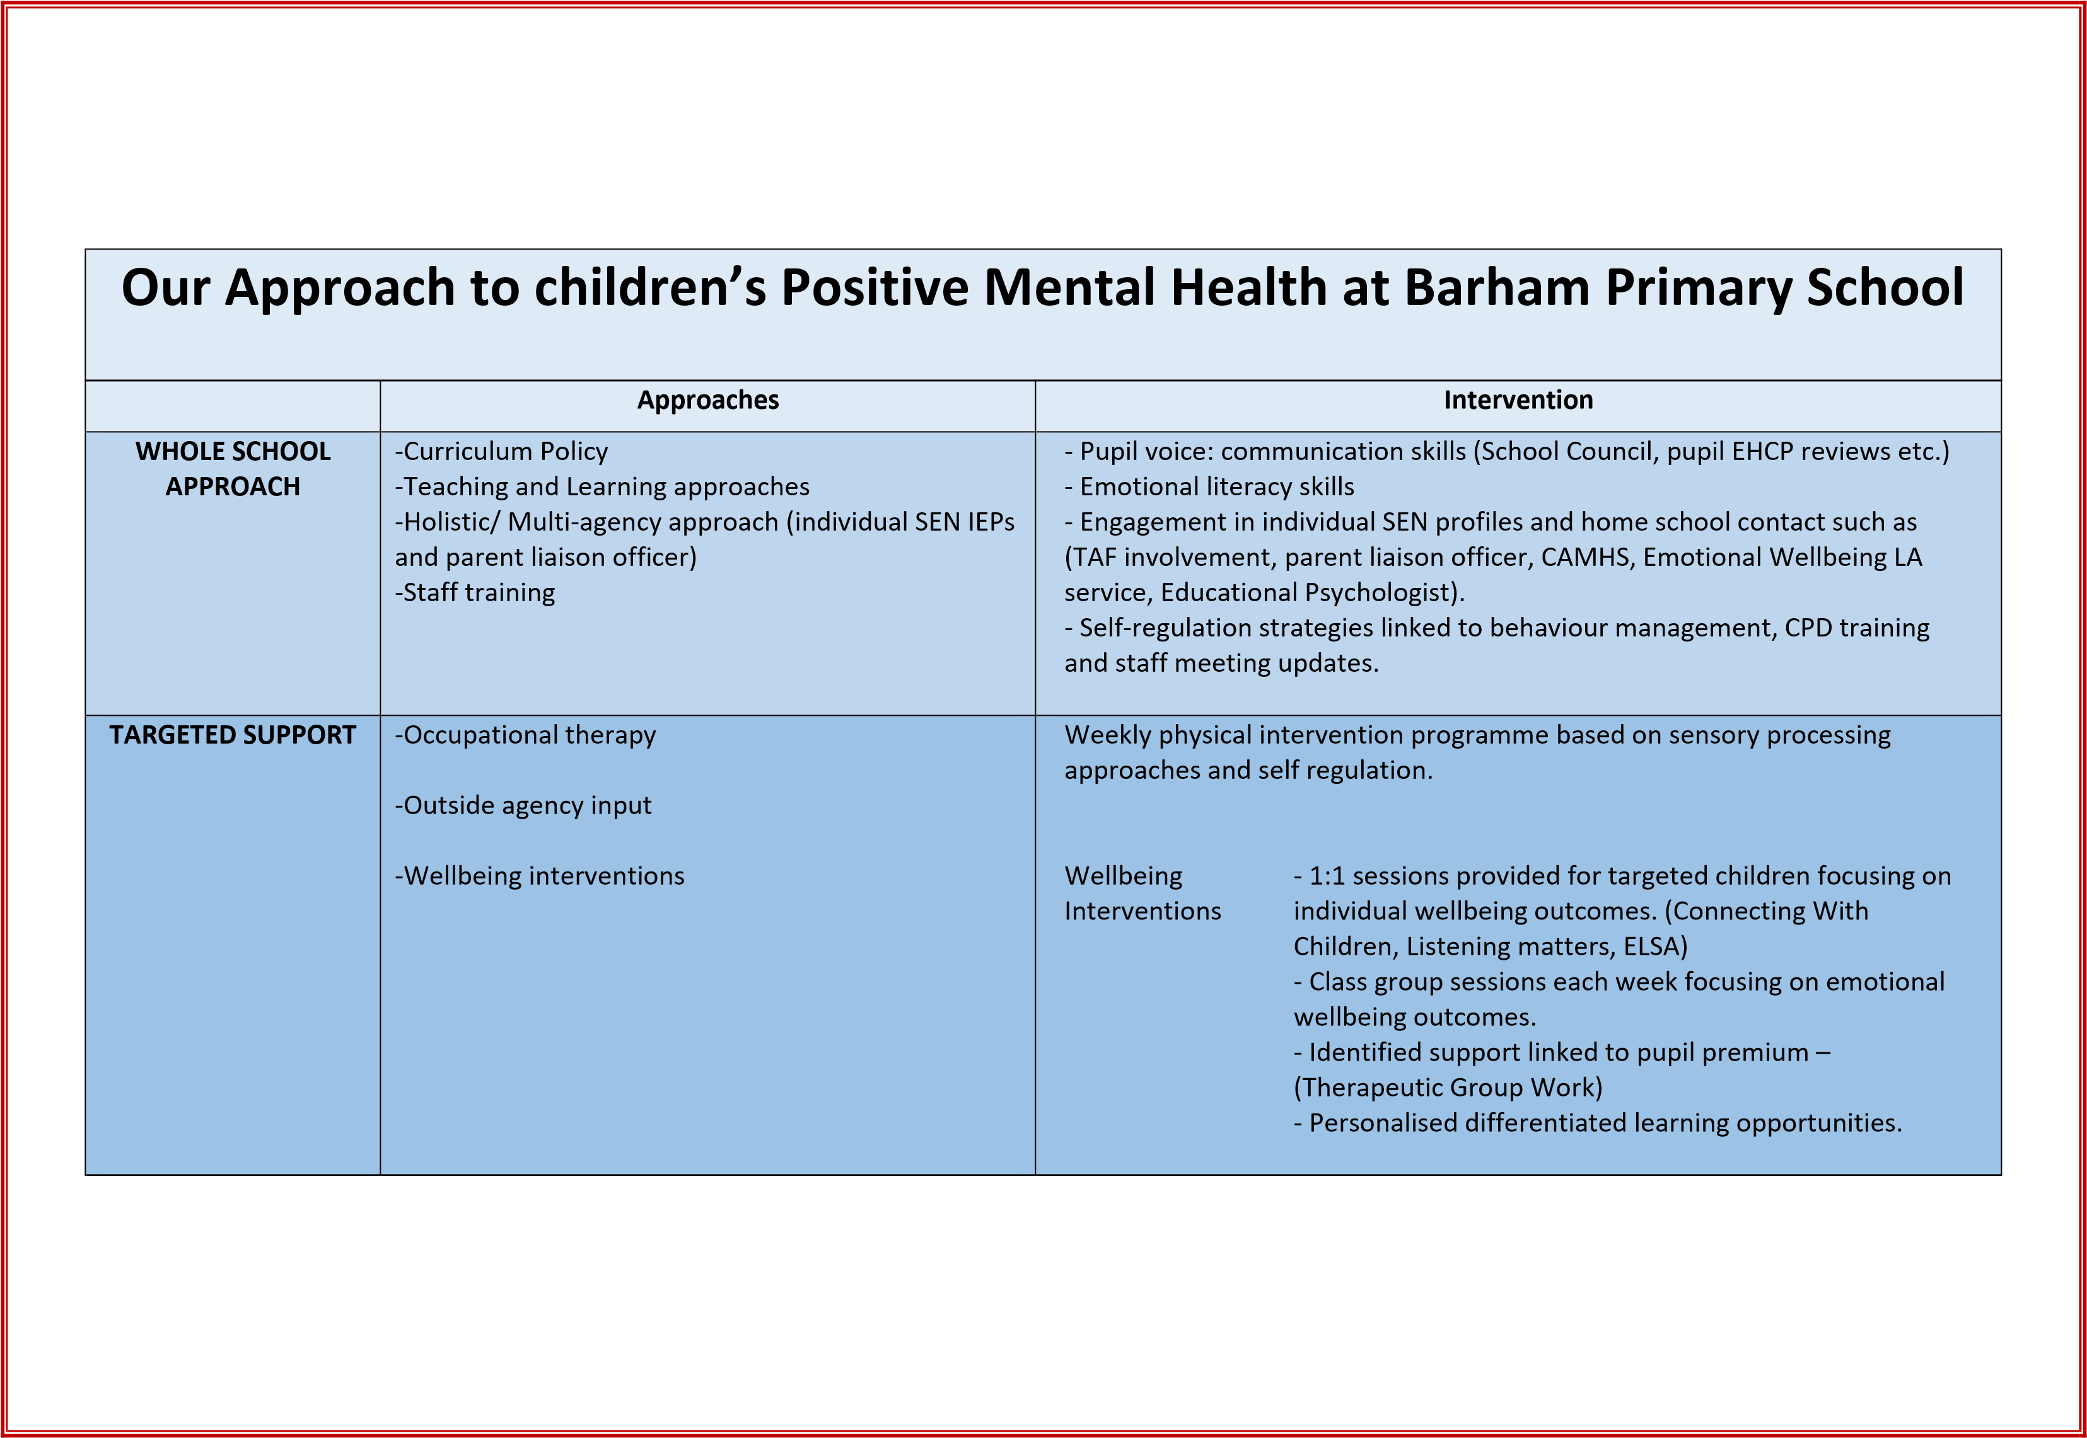

Our Approach to Staff wellbeing and Positive Mental Health at Barham Primary School

 | Approaches | Intervention
WHOLE SCHOOL APPROACH | A senior leadership team and governing body committed to provide all staff with listening support in relation to emotional wellbeing and recognition of this within performance management / appraisal discussions.  Head of School open door policy.  Work life Support and Flexibility for personal wellbeing appointments within school time.  Library of resources and access to Education Support Partnership advice line.  Planned CPD opportunities. | Open door policy, contactable governing body and flexible EW appointment planning.  Information sharing from lead practitioners  Posters/ leaflets  Signposting to additional CPD courses  Care first package
WHOLE SCHOOL APPROACH OFFER | Emotional Wellbeing Staff meetings and Inset Days  Emotional Wellbeing information support file containing appropriate information in relation to emotional wellbeing as a tool for personal review, reflection and private advice. | Planned staff meeting with guest speakers from trained professionals.  Care first package  SENDCo to provide an EW advice file.
TARGETED SUPPORT | Debriefing/support sessions for all staff working in classes for pupils with complex medical needs or challenging behaviour from the Head Teacher, Deputy Head, SENDCo.  Significant incidents – debriefing/counselling with a trained professional for all staff involved in a significant incident.

